**Report Title:**

Construction, Control, and Design of the Power Measurement & Switching Module.

**Client:**

Profound Medical Inc, 2400 Skymark Ave #6, Mississauga, ON L4W 5K5, Canada

**Date:**

March 25th, 2022

**Power Measurement & Switching Module Components & Summary**

Power Measurement & Switching Module Summary:

The Power Measurement & Switching Module….

Internal Component Name/Description/Serial Numbers:

**National Instruments 6501 OEM digital I/O board**: This device is the data acquisition controller that is controlled by the computer and interfaces with all the other internal devices. Serves as both an input and output for the sensors, pump, and RF relay of the system and is the primary controlling device within the system.

*Serial number*: NI USB-6501 OEM

**Pasternak SP10T:** The electromechanical relay that switches RF channels. Functions as a normally open switch with a maximum frequency of 8 GHz, max power of 120 Watts, and operating voltage of 28 V. Uses a SMA connection. The common terminal is tied to +28 Volts and one of the 10 pins is tied to the low supply voltage to activate the corresponding channel.

*Serial number*: PE7160

**KMTronic USB Relay:** A single channel USB electromechanical relay that activates and deactivates the DAQ interface boards +28 Volt supply. Controlled by USB connection to the computer.

**Mini-Circuits PWR-6GHS Power Meter:** The device uses a total of 2 PWR-6GHS power meters to monitor the RF power being transmitted through the signal line. The power meters work at an impedance of 50Ω and operate from 1MHz to 6GHz. The two power meters are connected to the USB hub and their data passed to the computer via USB type-b.

*Serial number*: PWR-6GHS

**Power Measurement & Switching Module Functional Diagram**

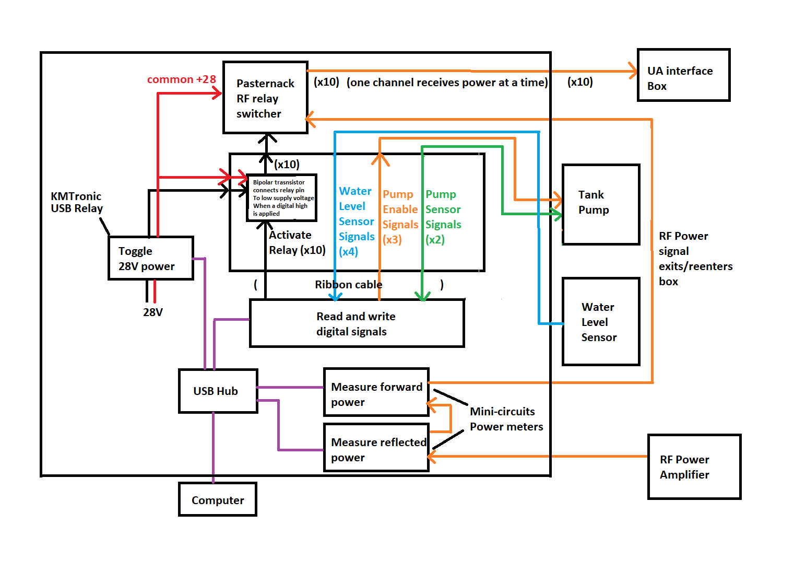

**Power Measurement & Switching Module DAQ – Connector Addresses**

|  |  |  |
| --- | --- | --- |
| **NI-DAQ Software Address** | **NI-DAQ Connector Pin Location** | **Physical Module Connection** |
| **P0.0** | **Pin 17** | **RF Relay Channel #1** |
| **P0.1** | **Pin 19** | **RF Relay Channel #2** |
| **P0.2** | **Pin 21** | **RF Relay Channel #3** |
| **P0.3** | **Pin 23** | **RF Relay Channel #4** |
| **P0.4** | **Pin 25** | **RF Relay Channel #5** |
| **P0.5** | **Pin 27** | **RF Relay Channel #6** |
| **P0.6** | **Pin 29** | **RF Relay Channel #7** |
| **P0.7** | **Pin 31** | **RF Relay Channel #8** |
| **P1.0** | **Pin 1** | **RF Relay Channel #9** |
| **P1.1** | **Pin 3** | **RF Relay Channel #10** |
| **Ground (No Signal)** | **Pin 6** | **Liquid Level** |
| **P2.2** | **Pin 12** | **Liquid Level** |
| **P1.2** | **Pin 5** | **Liquid Level** |
| **P1.5** | **Pin 11** | **Liquid Level** |
| **Ground (No Signal)** | **Pin 2** | **Pump Enable** |
| **P1.6** | **Pin 13** | **Pump Enable** |
| **P1.4** | **Pin 9** | **Pump Enable** |
| **Ground (No Signal)** | **Pin 2** | **Pump Monitor** |
| **P1.3** | Unknown (fill later) | **Pump Monitor** |